Topic | Shakespeare’s Stratford
Science Unit | Animals including humans
Curriculum Objectives | Content:  - Identify and name the main parts of the human circulatory system, and describe the functions of the heart, blood vessels and blood  - Recognise the impact of diet, exercise, drugs and lifestyle on the way their bodies function  - Describe the ways in which nutrients and water are transported within animals, including humans.  Working scientifically:  - Ask a range of significant scientific questions based on scientific concepts. (Anchor Tasks)  - Independently, select, plan and carry out a variety of practical enquiries including, recognising and controlling variables and explaining why these variables needs to be controlled (L4).  - Record data and results of increasing complexity using relevant scientific language; scientific diagrams and labels (L1-2); classification keys; tables, scatter graphs, bar and line graphs (scale agreed independently) (L5).  - Choose the most effective way to record data and results from a range of choices (L4-5).  - Report and present findings from enquiries, including conclusions, causal relationships and explanations of and degree of trust in results, in oral and written forms such as displays and presentations (L5).  - Explain in detail why something happened, identifying casual relationships and using relevant scientific language from year 6 (L5).  - Identify patterns in their data/charts and look for casual relationships in data. Spot unexpected results that don’t fit the pattern and suggest reasons for this (L5).  - State how confident they are that their results are reliable and give reasons for this. Describe how to improve planning to get more reliable results (L5).  - Plan the most appropriate type of scientific enquiry to answer questions including: observing over time (L4); pattern seeking; identifying, classifying and grouping; comparative and fair testing (controlled investigations, including recognising and controlling variables); and researching using secondary sources.
Lesson Objectives | Week 1 | Week 2 | Week 3 | Week 4 | Week 5 | Week 6
 | To learn the parts of the human circulatory system and the functions of blood vessels and blood. | To learn the parts of the human circulatory system and describe the functions of the heart. | To learn how nutrients and water are transported within animals. | To learn to investigate the impact of exercise on the body. | To learn to record results and draw conclusions. | To learn the impact of diet, drugs and lifestyle on the body.
Key Vocabulary | heart | pulse | pump | blood vessels | lungs | oxygen
 | carbon dioxide | circulatory system | drugs | liver | kidney | lifestyle
 | arteries | veins | lumen | vena cava | capillaries | blood
 | valves | ventricle | oxygenated | deoxygenated | calorie | breathing rate
 | aerobic | anaerobic | illegal | legal | alcohol | smoking
 | medicine | energy | absorption | heart/lung disease | metabolism | tobacco
 | +Year 2 and 3 vocabulary around diet and muscles
Possible lesson ideas | 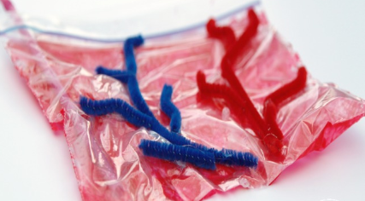  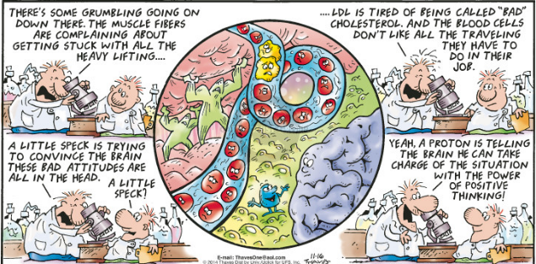  - Lesson 1: Look at different materials such as a sponge, straw and a tube how would blood flow differently through these? Blood cells- comic give the blood personalities explaining their role, could they do some illustrations.  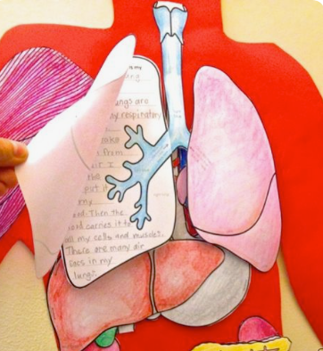  - Lesson 2: Show pump which will allow them to see how the heart pumps blood around the body by contracting and relaxing. Could they make own pumps out of balloons? https://kidsactivitiesblog.com/8992/learn-about-the-heart-2  - Lesson 1-2: Children to draw round a partner and draw parts of the circulatory system and label. Look at own bodies can they see any veins? If time do an overview of in books of the functions of the circulatory system.https://www.schoolsofkingedwardvi.co.uk/ks2-science-year-6-2-animals-circulatory-system/’  - Lesson 3: https://www.educationquizzes.com/ks2/science/. If amounts of each food group are in the correct proportion then we have a balanced diet. Write a diet plan for the athlete that they researched and an elderly person. How do they differ? Alternative is that the children look at different cooking books and plan a healthy three course meal. Any cooking? Read Oliver Twist- pg20 ready science resource look at children’s’ diet.  - Lesson 4: How does exercise change the body/heart rate/pulse? https://www.stem.org.uk/elibrary/resource/34279 https://www.tes.com/teaching-resource/the-effects-of-exercise-on-our-pulse-6324043 Look at exercise one on BBC website: https://www.bbc.co.uk/teach/terrific-scientific/KS2/zkty8xs Research fitness regimes of some athletes. Children to create fitness leaflet or top trump cards on their athlete. Could they talk to a fitness instructor?  - Lesson 6: Optional – could use secondary research  Drugs  - positive and negatives of drugs,  - talk about link between smoking and cancer.  - Cross section picture of lungs and liver link between alcohol and liver function.  - Link between size of body and alcohol-smaller person less alcohol before damage. Same with age.  - Good drug examples- insulin, inhaler, Penicillin  - Whole unit topic: https://www.hamilton-trust.org.uk/science/year-6-science/art-being-human/  - Whole unit topic: https://developingexperts.com/s/unit-library/units/40  - https://www.stem.org.uk/resources/community/collection/13109/year-6-animals-including-humans

